**Name:** Chillara V L N S Pavana Vamsi

**Reg.no:** 21BCE5095

**Date:** 05/1/2023

**Faculty:** M Sivagami

## 

## L21_L22_Lab3 Exercises

1. 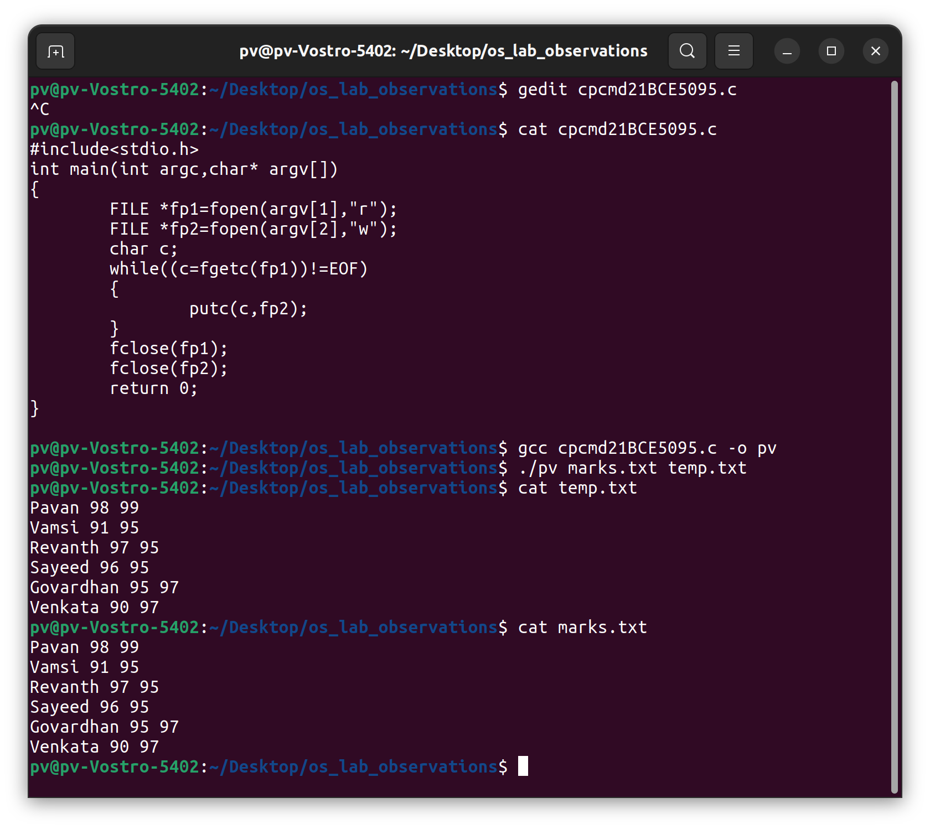**Simulate CP Linux command using C**
2. 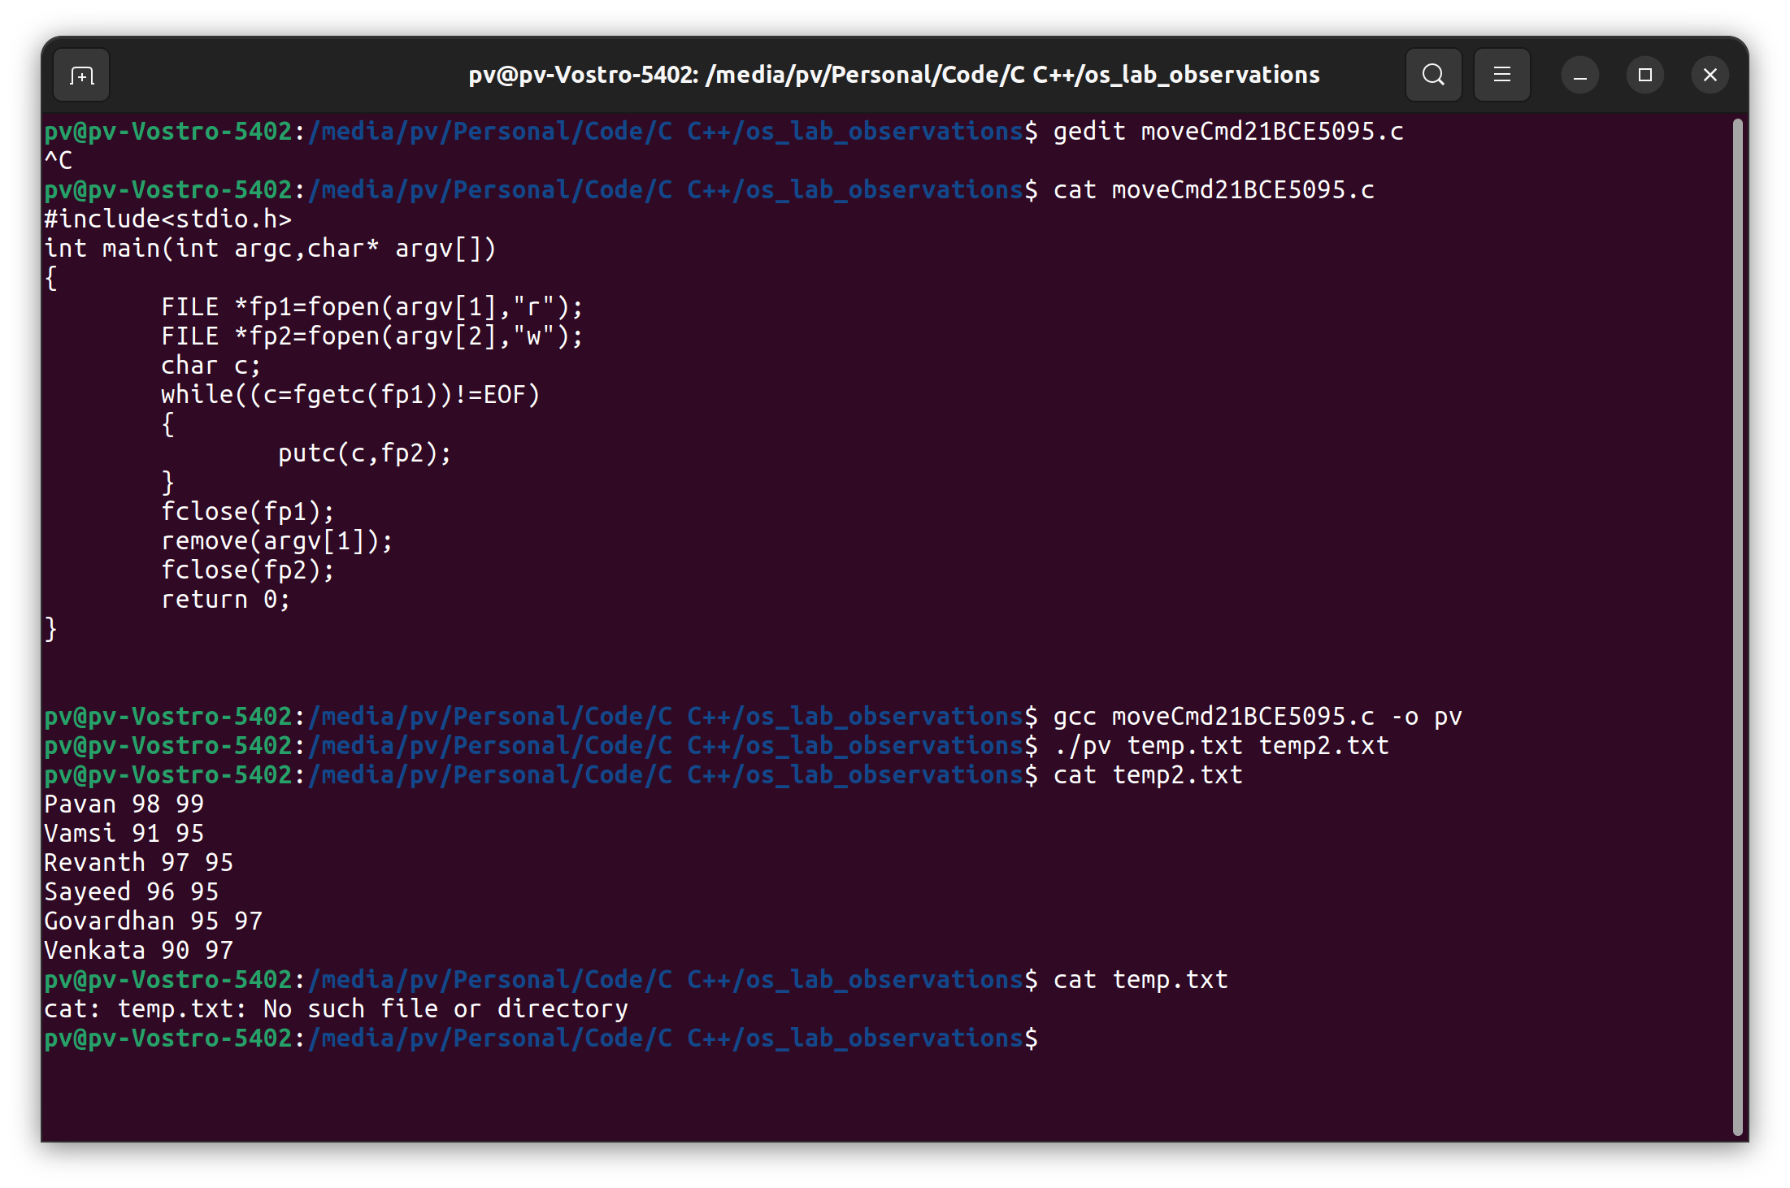**Simulate MV Linux command using C**
3. 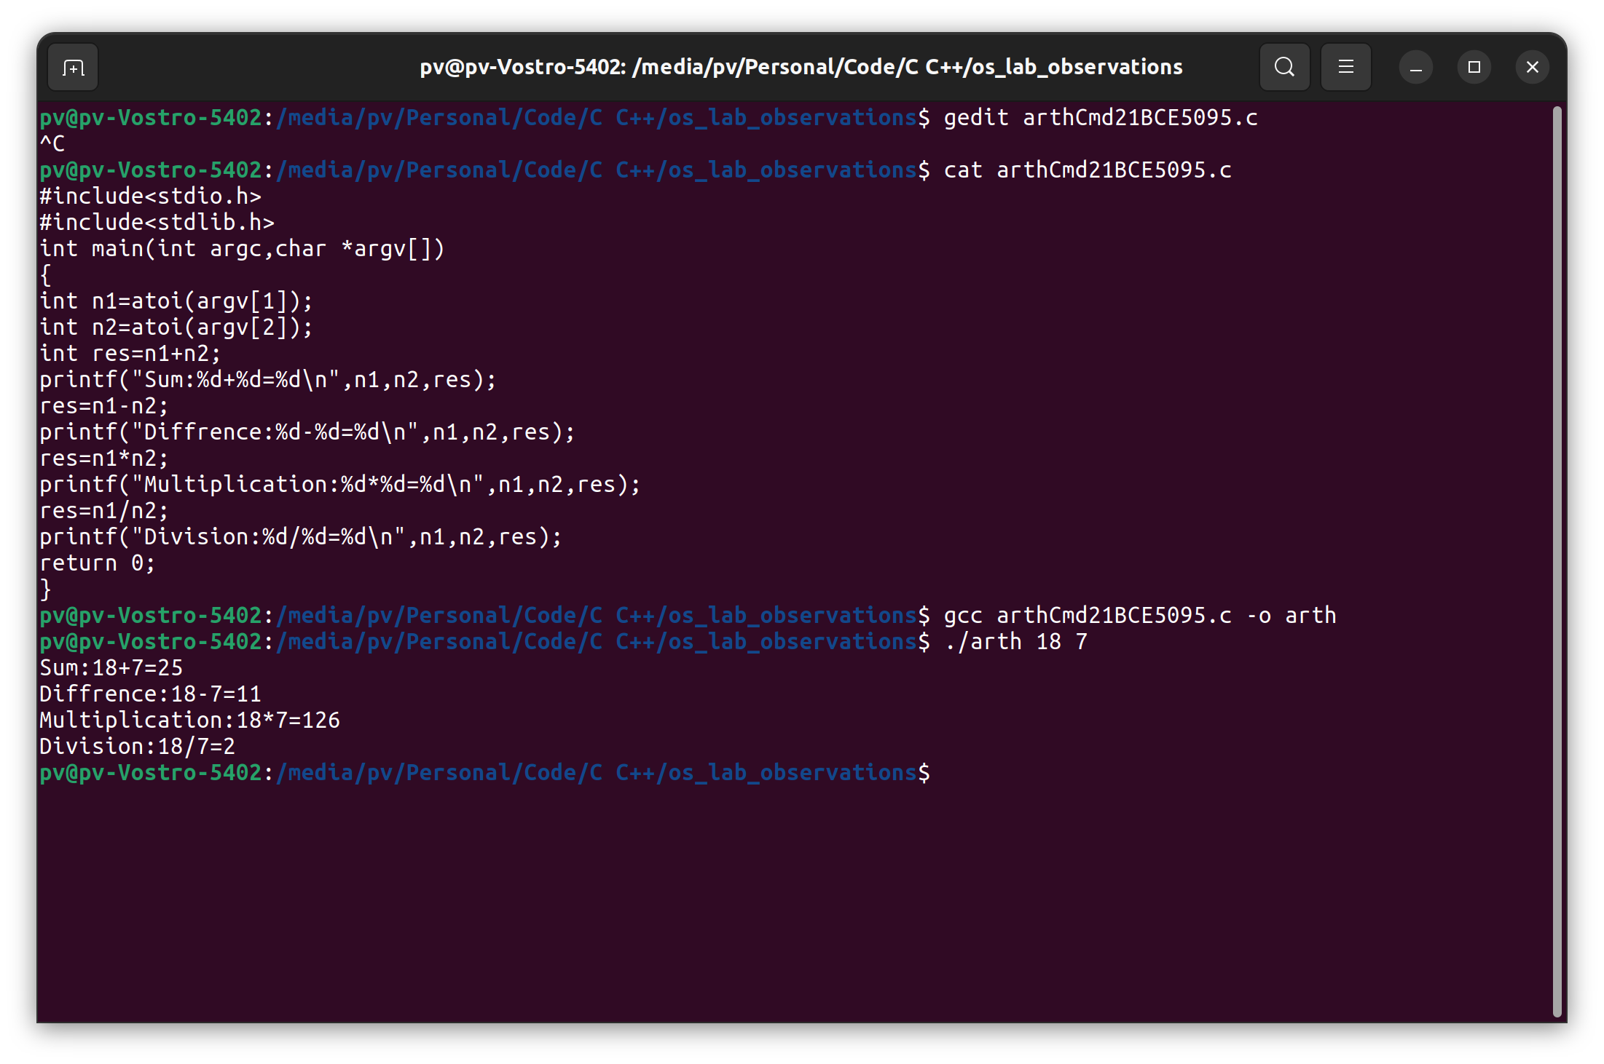**Perform arithmetic operations using command line arguments**
4. 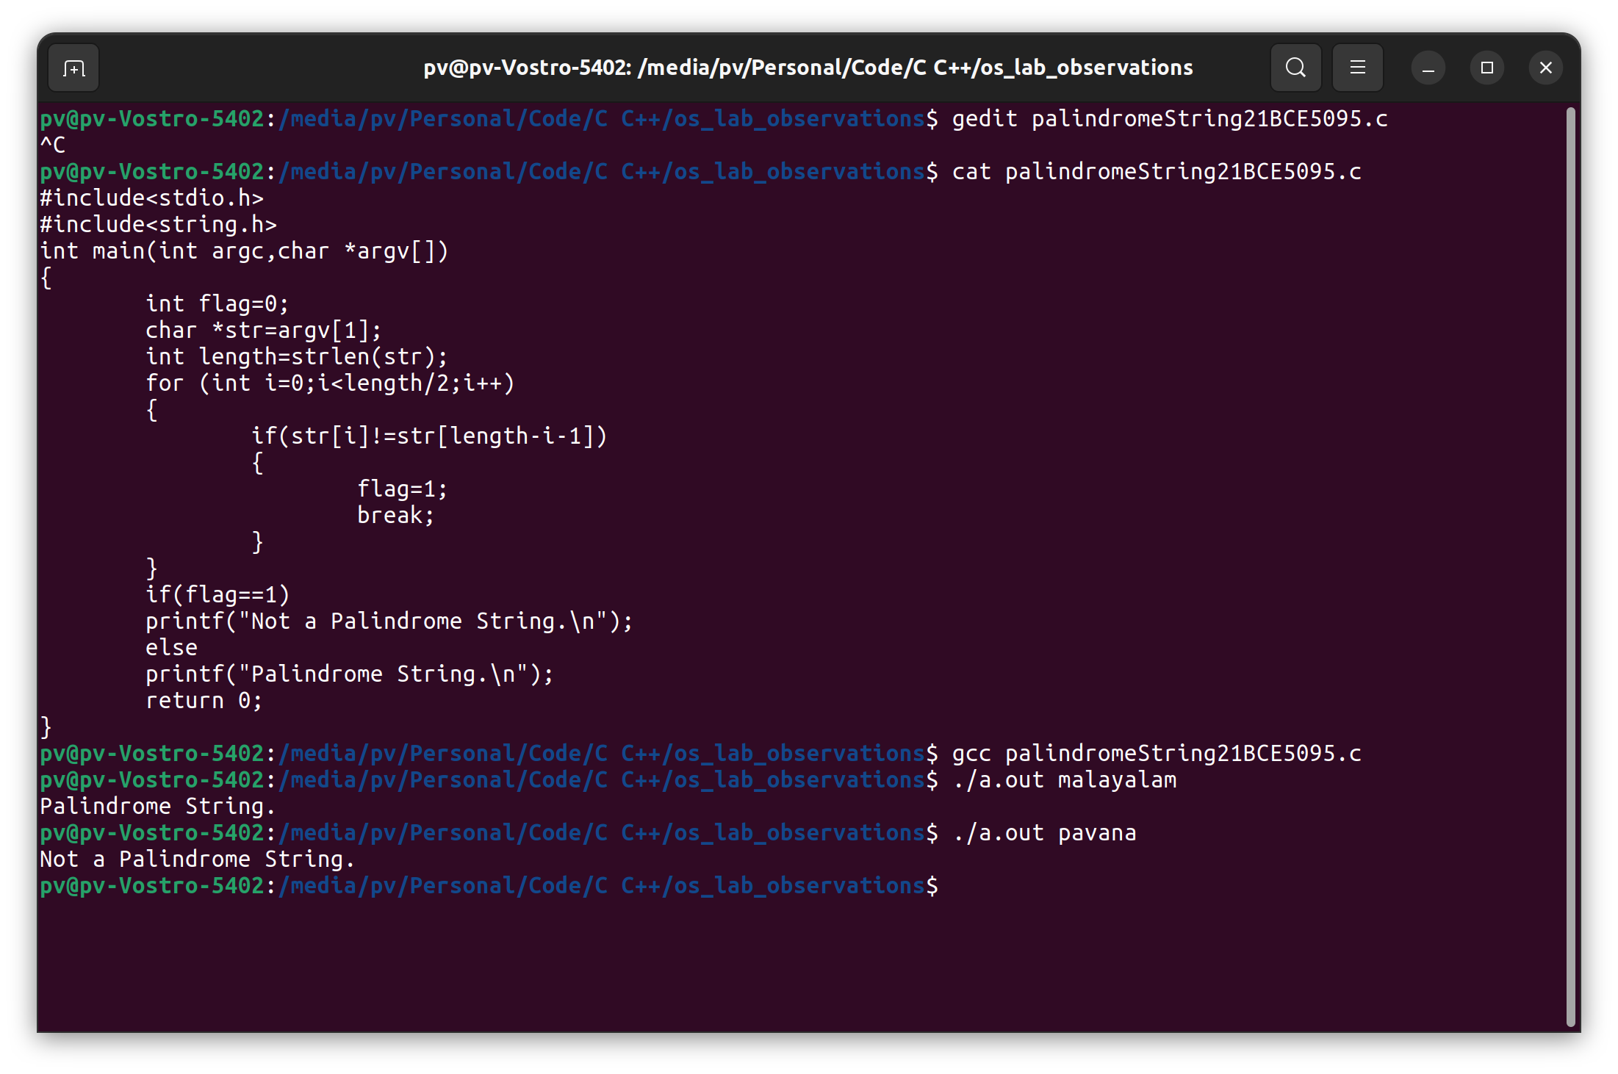**Check whether the given string is palindrome or not and ensure to take the input while executing the program**
5. 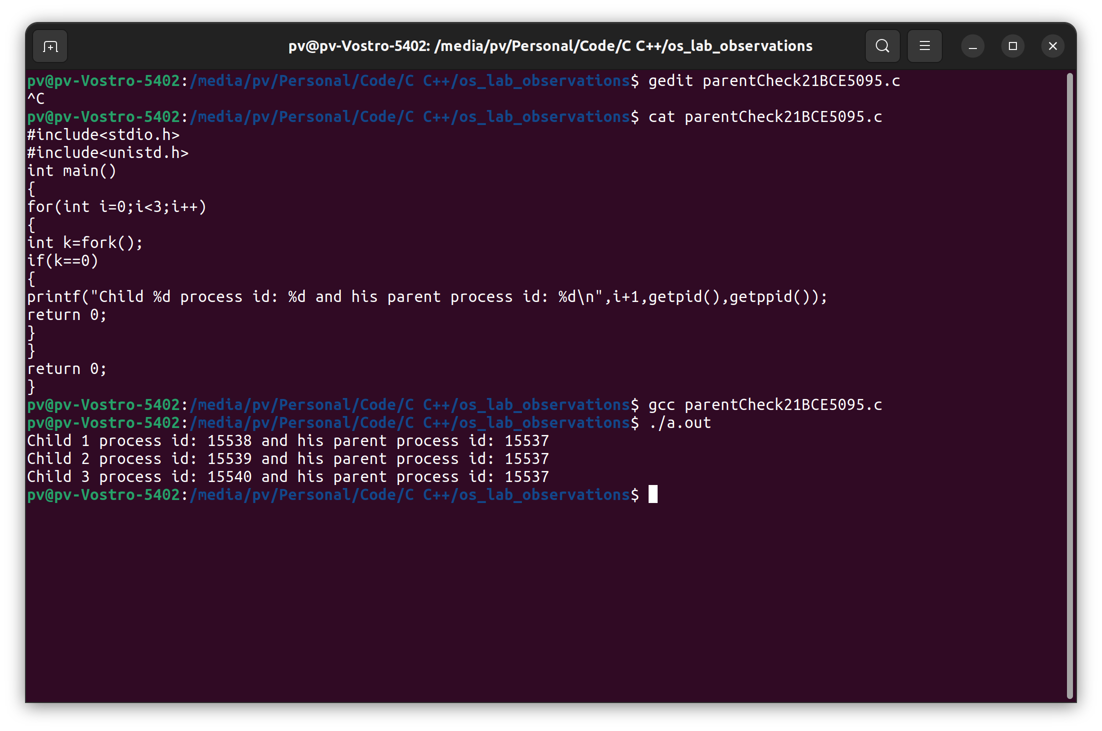**Create 3 child processes from the same parent process and show the child processes are created from the same parent process.**
6. **Discuss the use of Command line arguments in C**

* Command line arguments are parameters that are passed to a program when it is executed from the command line. This helps us to control the values from outside instead of declaring everything inside the code which is fixed and we can’t modify that from outside.
* In the code we should make some change in the main function by passing argument count and argument vector as parameters to that main function
* int main (int argc, char* argv [])
* argv [0] represents program name
* argv [1] to etc represents the arguments you passed during the execution in an order.